Test Summary for Lab 3

(*Shruti Ratna Charugulla*)

Contents

Purpose 1

Application Overview 1

Manual testing 2

List of all test cases along with output and description 2

Testing scope 3

In Scope 3

Out of Scope 3

Metrics 4

Test cases 4

Defects 4

Test Environment & Tools 4

Exit Criteria 4

Conclusion/Sign off 4

# Purpose

This report provides a summary of the manual testing conducted to verify rules for user ID logon.

# Application Overview

The application is a command-line based authentication server written in Python. It allows a user to do three things listed below.

* Create an account with a valid password.
* Log in with a valid user name and password.
* Change the password of an existing account.

The application uses a simple database file to keep track of user statuses. The file is located in a temporary folder that is unique to an operating system.

# Manual testing

## List of all test cases along with output and description

The login application was tested manually. A brief description along with the output of each manual test is provided below.

1. Attempted to log in with a non-existent user account resulted in an *Access Denied* message. See snapshot of the Winscp terminal window below:

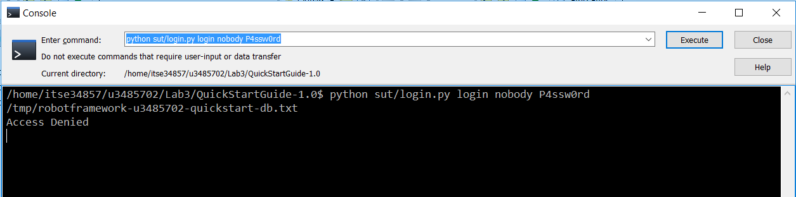

In this test, the access was rightly denied when a non-existent user account called **login** was used to login.

1. Attempted to log in with an invalid password also resulted in an *Access Denied* message.
2. Created a user account with valid password login that resulted in *SUCCESS* message as shown in the snapshot below.

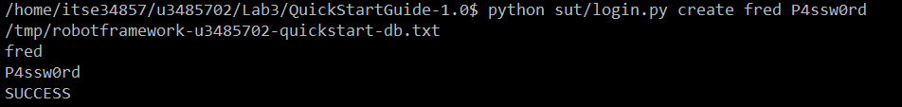

In this test, a user account with user name *fred* and password *P4ssw0rd* was created.

1. Logging in with the user name and password created in step #3 resulted in *Logged In* message as shown in the snapshot below.



Access was rightly given to the user *fred* since correct credentials were used to login.

1. When a password that was not 7 to 12 characters long was used, the application threw the error *Creating user failed: Password must be 7-12 characters long.* See snapshot below.

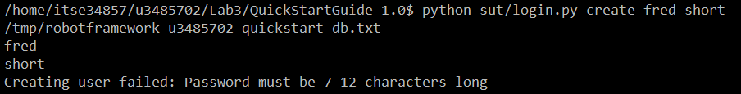

1. Also, when a password that did not contain a combination of both lower case and upper case letters was not used, the application threw the error *Password must be a combination of lowercase and uppercase letters and numbers.*

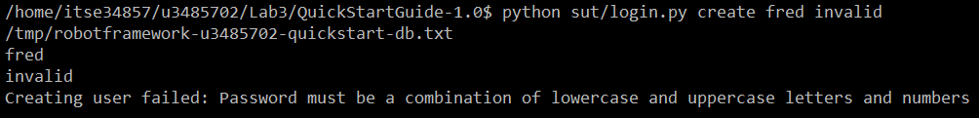

1. Changing password with invalid credentials i.e. wrong password resulted in *Access Denied* message as shown in the snapshot below.



1. Changing password with valid credentials but with a password that does not conform to the password requirements resulted in an error as shown below in the snapshot.



1. Changing password with valid credentials and with a valid new password resulted in *SUCCESS.* See snapshot below.



# Testing scope

## In Scope

Only the scenarios presented in the previous section were within the scope of the testing effort.

## Out of Scope

* Performance testing was out of the scope of this testing effort.
* Only a limited number of users (at most two) were created in the database.

# Metrics

## Test cases

|  |  |  |  |
| --- | --- | --- | --- |
| Test Cases Planned | Test Cases Executed | TCs Passed | TCs Failed |
| 9 | 9 | 9 | 0 |

## Defects

None

# Test Environment & Tools

Below is a table that includes a brief overview of the software and hardware setups used to execute the test cases described in this report.

|  |  |
| --- | --- |
| Computer hardware | GenuineIntel x86_64 1800 MHz, 8GB RAM |
| Manual testing script language | Python |
| OS | Ubuntu 14.04.5 LTS (GNU/Linux 3.13.0-52-generic x86_64) |

# Exit Criteria

* All planned test cases are to be passed.
* No critical defects found.

# Conclusion/Sign off

All exit criteria were met and satisfied. This application can ‘Go Live’.